

WebAPI Final Project

Gavin Atkin, Tammy Husnetdinova,

and Erik Nelson

*Spring 2019*

**About:**

2FIVEEIGHT is an evolution on social media for the next generation of youth. Designed to be a reduced stress experience in an ever-connected society. With the intentional omission of “likes,” our users will no longer feel the pressure to tie their self-worth to a non-consequential number system. We believe strongly that our users deserve more than a popularity ranking system based on a dopamine drip feedback loop.

**Features:**

* Image based post system.
* Each image is 258x258 pixels for stylish retro cohesiveness.
* Descriptions on posts can be up to 258 characters.
* Up-to five (5) hashtags per post.
* Global chronological feed to find new artists and personalities. Everyone has equal visibility.
* Chronological follower feed. See posts when they happen; you are not at the mercy of the algorithms.
* Long term privacy! Only your most recent post will stay for longer than a week. While this doesn’t stop anyone from downloading posts as they happen, no more worrying about your past mistakes coming back through smear campaigns.

**Design and Implementation:**

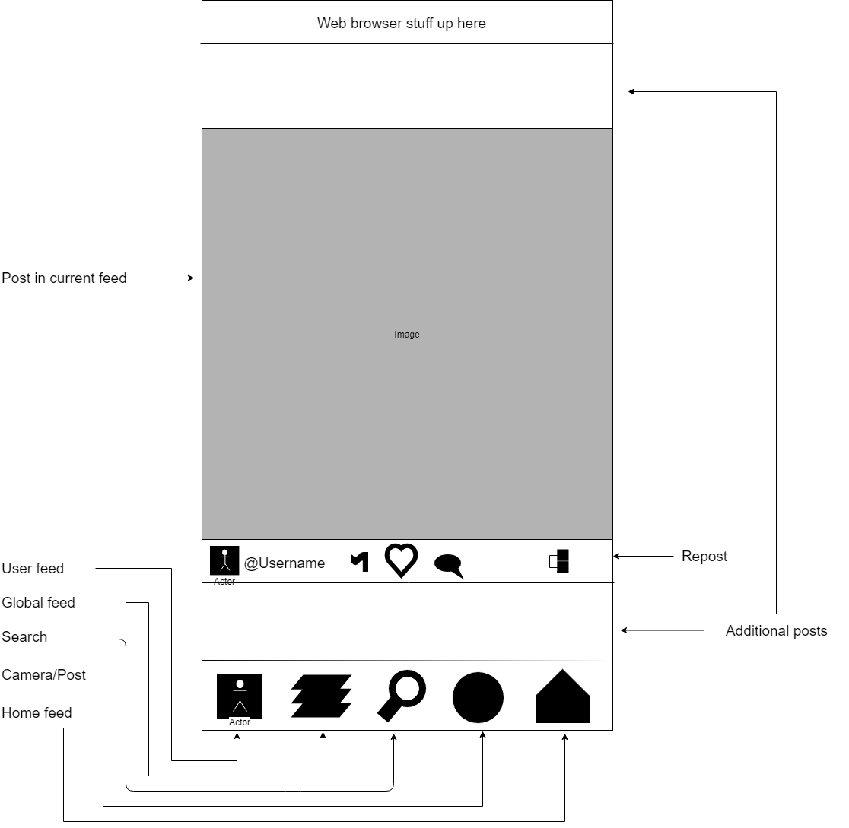

**Fig. 1: Interface mockup for mobile.**

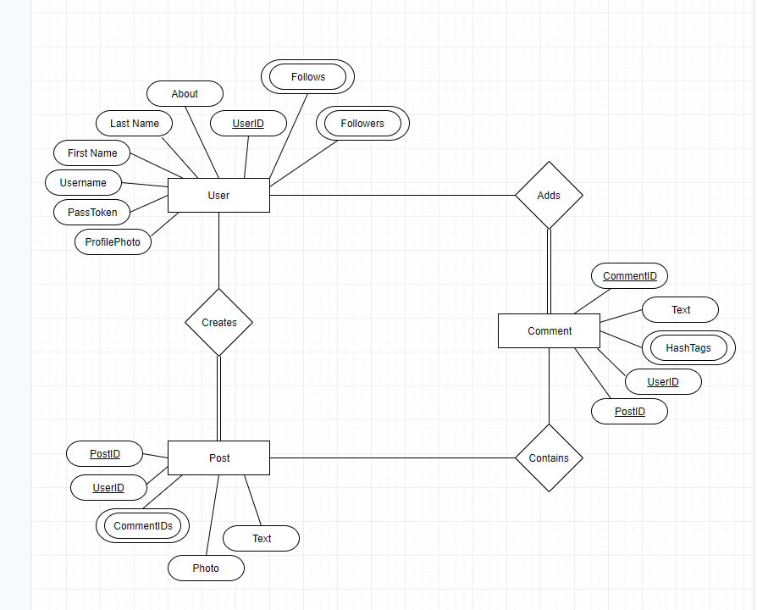

**Fig. 2: ER diagram for database design.**